

Date | 04 February 2026
Team ID | LTVIP2026TMIDS24102
Project Name | Heritage Treasures: An In-Depth Analysis of UNESCO World Heritage Sites
Maximum Marks | 2 marks

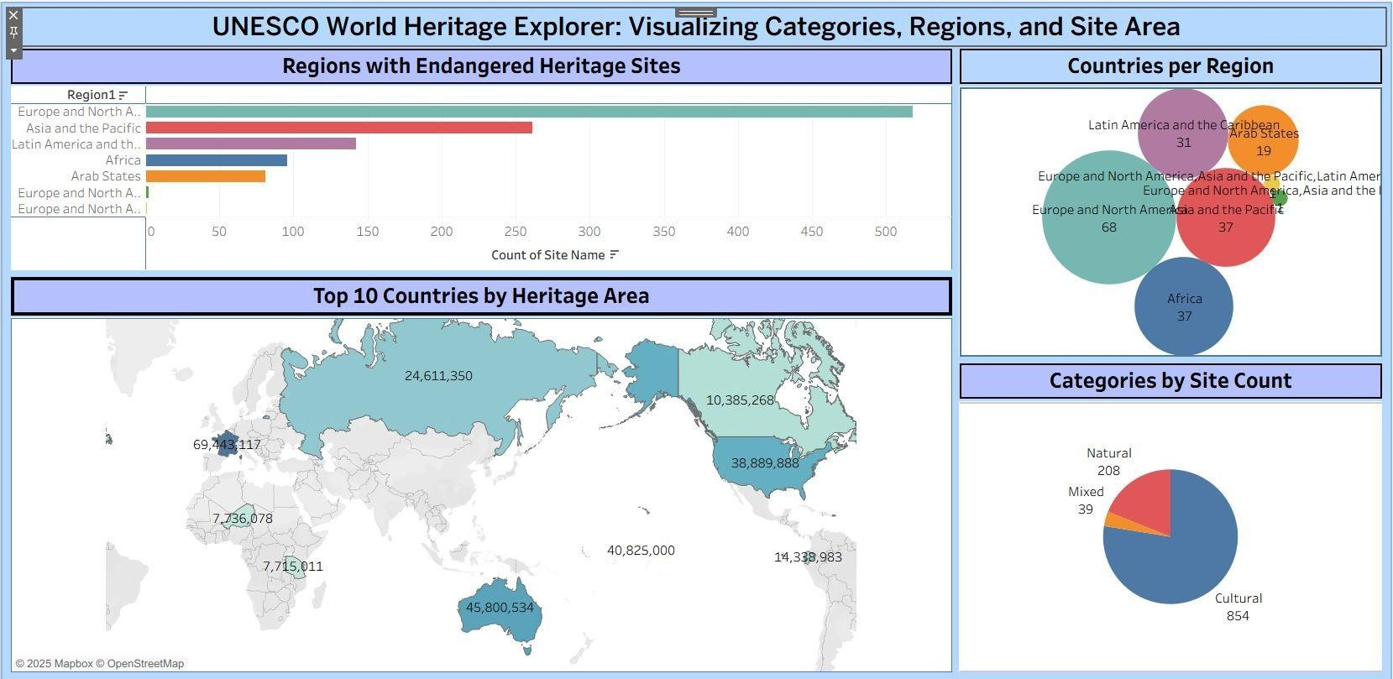

Dashboard-2:

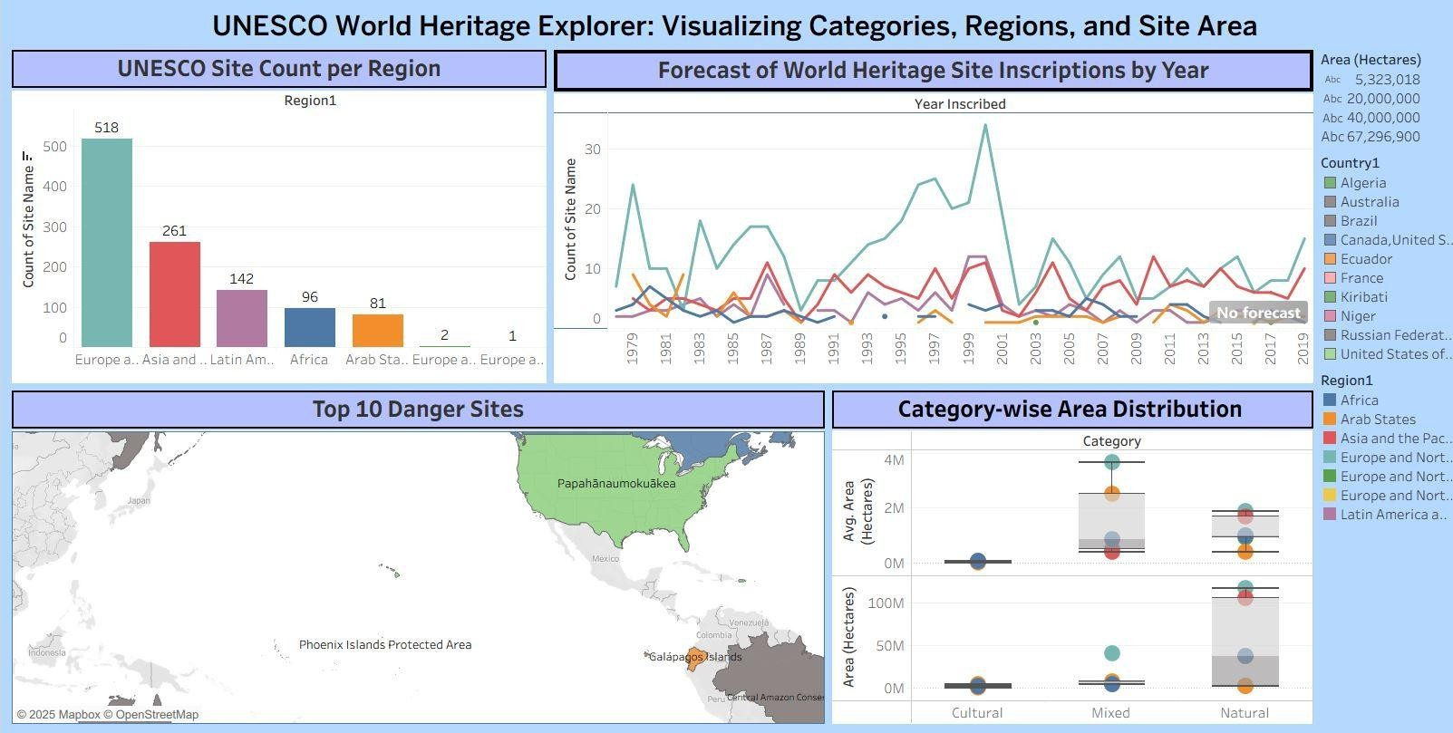

Link:
https://old.datahub.io/dataset/unesco-world-heritage-sites/resource/d4116195-44d8-4bc1-9f91-9b570870dc19
Dashboard-1:
https://public.tableau.com/views/htvisuals/Dashboard1?:language=en-US&publish=yes&:sid=&:redirect=auth&:display_count=n&:origin=viz_share_link

Dashboard-2:
https://public.tableau.com/views/dashboard2_17427206142080/Dashboard2?:language=en-US&publish=yes&:sid=&:redirect=auth&:display_count=n&:origin=viz_share_link

